**Phillips Curve & Okun’s Law Analysis**

A project work done in partial fulfilment of the “**Certificate course on Data Analytics & Business Intelligence**”



Submitted by:

ARAV BATHLA

Certificate Course on Data Analytics & Business Intelligence Batch-11

Shaheed Sukhdev College of Business Studies

November, 2024

**Acknowledgement**

I would like to express my heartfelt gratitude to our supervisor, **Dr. Rishi** **Rajan Sahay**, for his invaluable guidance and support throughout this project. This project helped me to explore and undertake research work and gaining practical knowledge and expertise to perform tasks. I also extend my heartfelt thanks to the **Shaheed Sukhdev College of Business Studies, University of Delhi** for providing the necessary resources and facilities.

Thanking you,

**Arav Bathla**

**Declaration**

I, **Arav Bathla**, hereby declare that the project entitled "**Phillips Curve and Okun’s Law Analysis**" is a result of my original research work was carried out under the guidance and supervision of **Dr. Rishi Rajan Sahay, Assistant Professor at Shaheed Sukhdev College of Business Studies, University of Delhi.**

This project work is undertaken as part of my **certificate course in Data Analytics and Business Intelligence** and is submitted in partial fulfilment of the requirements for the **award of the certificate of Data Analytics and Business Intelligence at Shaheed Sukhdev College of Business Studies, University of Delhi.**

I affirm that the research and findings presented in this project are genuine. All sources of information and data have been acknowledged appropriately.

I also declare that any help received in carrying out this project and preparing the report has been duly acknowledged.

**Abstract**

This project, titled *"****Phillips Curve and Okun’s Law Analysis****,****"*** conducts a comparative time-series regression analysis between the United States and Japan to examine the empirical relationships among unemployment, inflation, and economic growth. By applying the Phillips Curve and Okun’s Law regression models, the study aims to estimate these models' parameters and assess their predictive power in the context of contemporary economics.

The dataset includes key macroeconomic indicators—Inflation, Unemployment, and GDP Growth Rate—to facilitate a comprehensive analysis. The study employs descriptive analysis to examine the relationship between the variables, exploratory data analysis to visualise and understand the relationships between variables, followed by regression and residual analysis to estimate the Phillips Curve and test the validity of Okun’s Law across both countries. The findings provide insights into the applicability of these classic economic models in different economic contexts, highlighting any similarities or divergences between the U.S. and Japanese economies.

**INTORDUCTION**

**Phillips Curve**

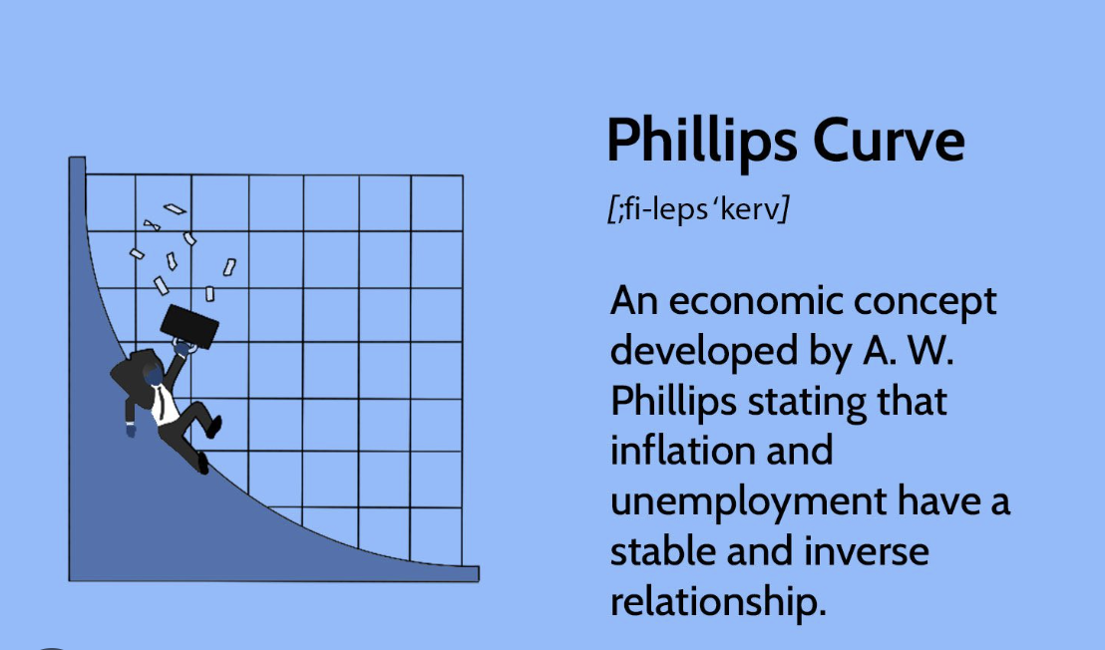

* The Phillips Curve illustrates an inverse relationship between inflation and unemployment, suggesting that as unemployment decreases, inflation tends to rise, and vice versa. Proposed by economist A.W. Phillips in 1958, this concept has been central to macroeconomic theory, helping policymakers understand the trade-off between job growth and inflation control.

**Okun’s Law**

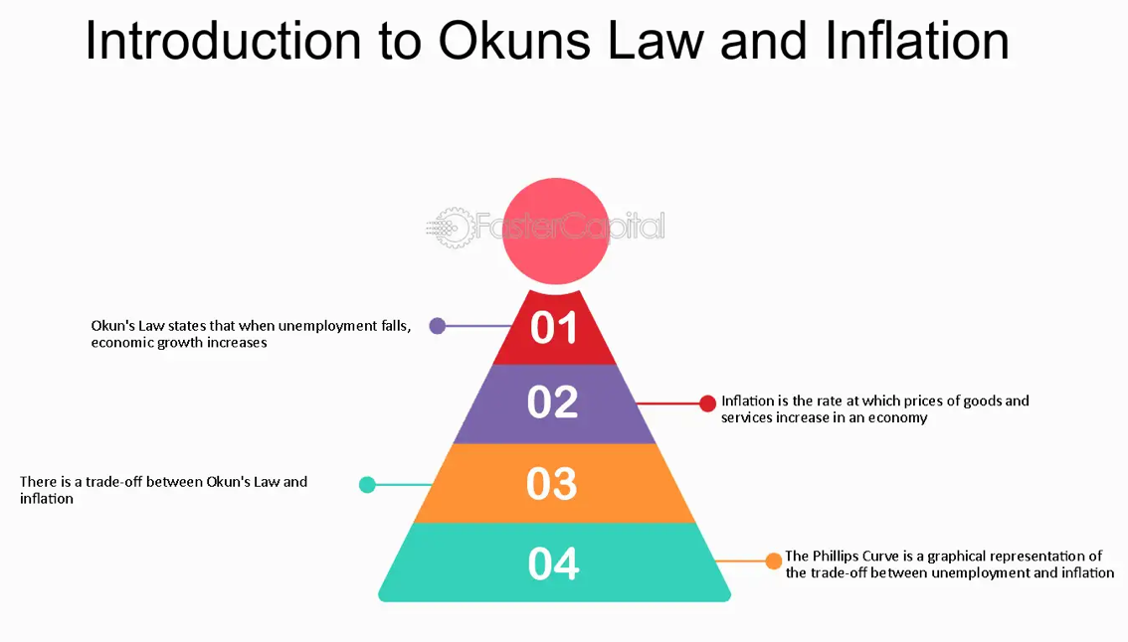

* Okun's Law describes the relationship between unemployment and economic output, suggesting that a 1% decrease in unemployment typically results in a 2-3% increase in GDP growth. Named after economist Arthur Okun, this empirical observation highlights how shifts in labor markets can significantly impact economic productivity. It serves as a simple tool for understanding how employment fluctuations relate to economic growth, making it useful for economic forecasting and policy decisions.

**Inflation**

* Inflation is the rate at which the general price level of goods and services rises over time, reducing purchasing power. It occurs when demand outpaces supply or production costs increase, leading to higher prices. Moderate inflation can signal a growing economy, while high inflation erodes savings and affects consumer spending. Managing inflation is crucial to maintaining economic stability and protecting consumers' financial well-being.

**Unemployment**

* Unemployment refers to a situation where some willing and able persons are unable to find work. It can be caused by a variety of factors, such as the decline of industries, changes in industrial sectors, technological changes, etc. High rates of unemployment may negatively affect economic growth, the decline in incomes for households, and may increase the average government expenditures on welfare programs. It is through unemployment reduction that the furtherance of economic stability with enhanced quality of life of individuals and communities can be promoted

**GDP Growth Rate**

* The growth rate in GDP measures the rate at which the economic output of a country increases over any particular period, normally indicating the health and productivity of an economy. A positive growth rate reveals expanding productions, increasing consumer spending, and a likely upward level of employment. Fast growth at times may bring about inflation, whereas low or negative growth indicates economic stagnation or recession.

**Research Objective**

* In the pursuit of understand the complex connections between key economic indicators, this report presents a comprehensive analysis of the Phillips Curve and Okun's Law, examining the historical relationship between inflation, unemployment, and GDP growth rate. By exploring these fundamental economic concepts, the report investigates how shifts in unemployment affect inflation rates and how changes in employment levels relate to GDP growth. Through data analysis and economic modelling, this study aims to provide insights into the relationship among these variables, contributing to a clearer understanding of economic stability and policy implications.

**METHODOLOGY**

**DATASET**

**USA**

It has 237 rows and 4 columns.

Following is the image of the dataset:

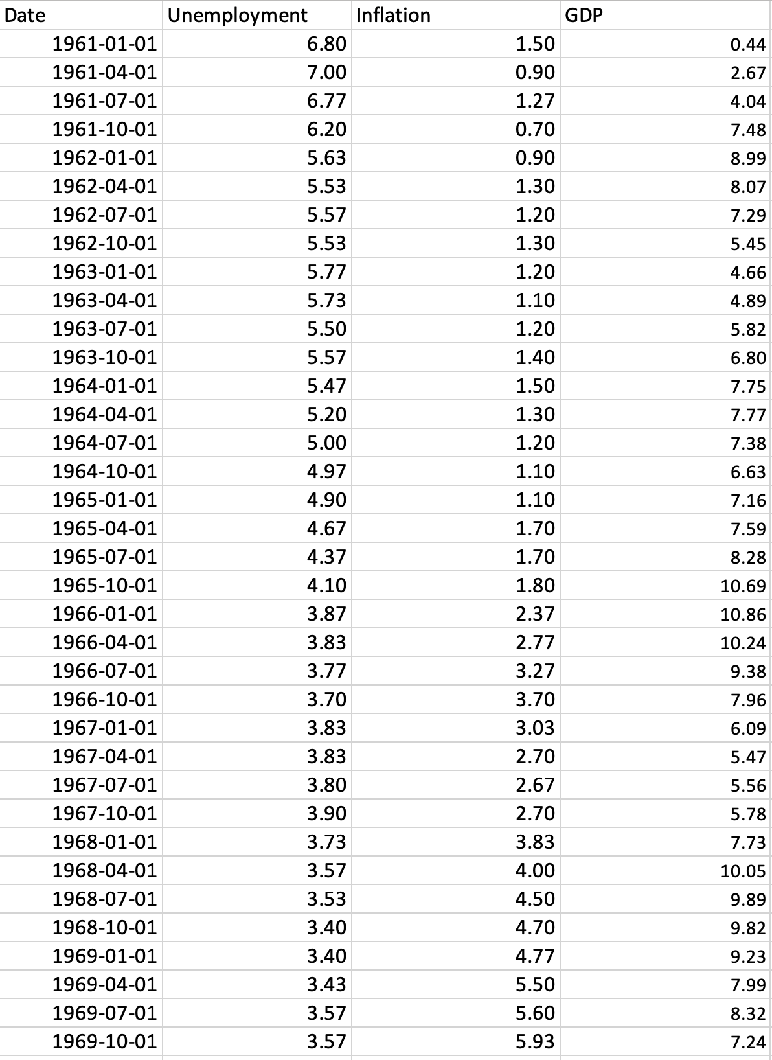

**Japan**

It has 237 rows and 4 columns

The following is the image of the dataset:

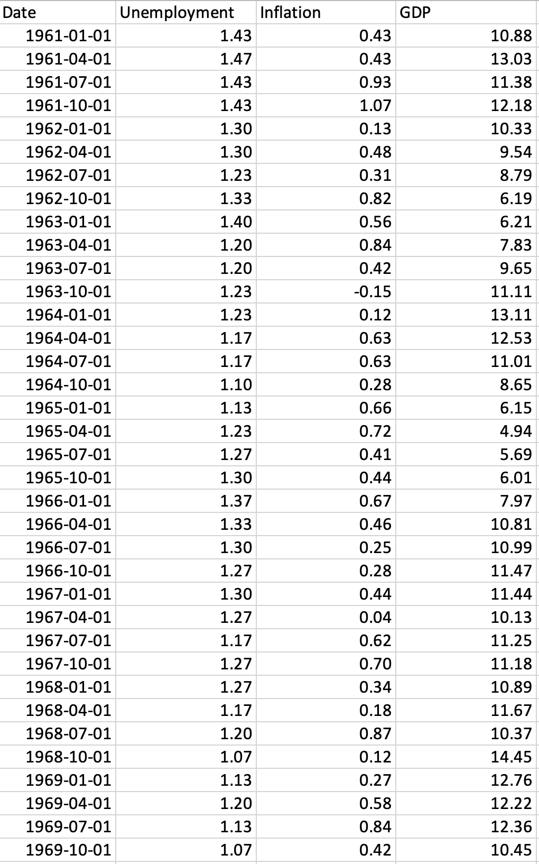

• This analysis uses data on inflation, unemployment, and GDP growth rates for the United States and Japan, sourced from the Federal Reserve Economic Data (FRED) database. Python-based descriptive statistics establish foundational trends for each variable, and visualizations—including line charts, histograms, and correlation heatmaps—highlight patterns and relationships over time.

To examine the Phillips Curve and Okun’s Law, regression models are employed: the Phillips Curve analysis quantifies the inverse relationship between unemployment and inflation, while Okun’s Law is tested by assessing the relationship between unemployment and GDP growth. This structured approach provides a basis for comparing economic dynamics in the U.S. and Japan, helping to clarify the interactions of these key economic indicators in each economy.

**DESCRIPTIVE ANALYSIS**

**Japan**

* Through the analysis, it can be seen that Japan’s average inflation rate is 0.12% over the years with a low variance of 0.14%. Japan had a shift from high inflation to long-term deflation between 1960’s to 2020 which resulted in its overall low average and fluctuation.
* Similarly to the inflation, the average unemployment rate is 2.8% with a low variance of 1.63%. This suggests a well-functioning labor market with periods of minor shifts due to economic conditions, but without significant instability.
* This result does not hold for GDP. While the average GDP is coming to be 3.7% which is moderate but the fluctuations from variance is whopping 16%. This is the result of various global economic conditions, domestic challenges, natural disasters, and shifts in trade and supply chains. These factors cause periods of rapid growth followed by contractions, resulting in the high variance observed in Japan’s GDP.

**DESCRIPTIVE ANALYSIS**

**USA**

* The analysis shows that the USA’s average inflation rate is around 3.7%, with high variance of 8.02%. This suggests that, rather than maintaining a steady 3.7% inflation rate, some years saw high inflation, while others experienced deflation. This fluctuation reflects periods of economic instability, with inflation surges in some years offset by declining prices or deflation in others.
* Unemployment rate is 5.97% with a comparatively lower fluctuation rate of 2.61%. This indicates a generally stable employment environment, with some economic resilience against sharp rises or falls in unemployment over time.
* The average GDP growth rate is 6.11% with a variance of 8.9 indicating a strong economic growth alongside significant fluctuations. This suggests periods of rapid expansion mixed with occasional slowdowns or contractions like the 2008 global financial crisis, reflecting economic cycles or external shocks that contribute to the economy's vulnerability to volatility

**EXPLORATORY ANALYSIS**

**Japan**

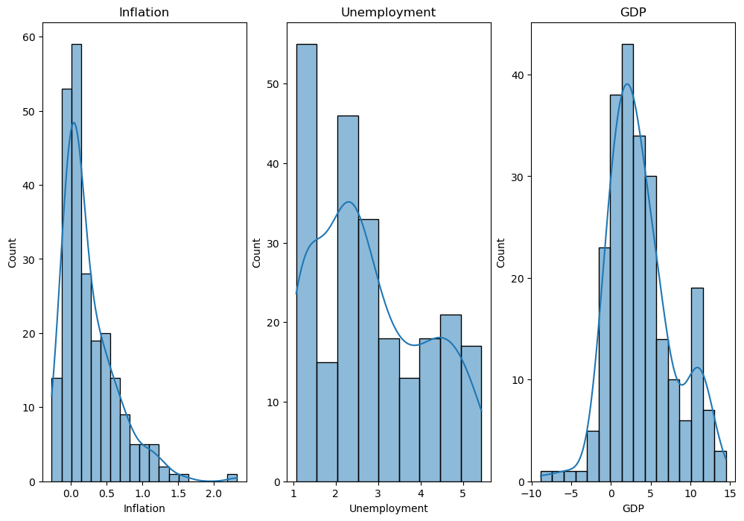

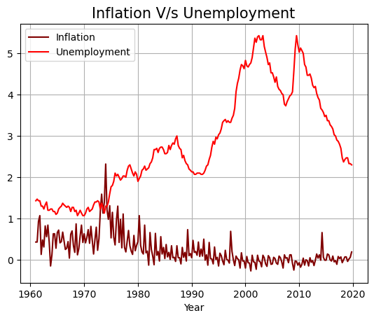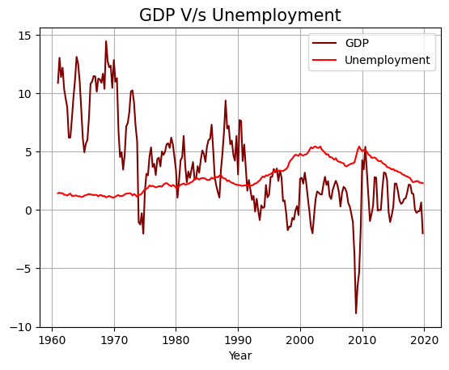

* The analysis indicates that GDP is more volatile than unemployment and inflation, both of which are relatively stable. GDP has shown a general decline over the years, reaching an all-time low of around -9% during the 2008 crisis, which highlights inconsistent economic growth and major contractions, particularly during global downturns. Meanwhile, unemployment displays moderate fluctuations, with notable increases during 2000-2010, likely linked to economic slowdowns.
* Examining distributions, all three variables—GDP, inflation, and unemployment—are positively skewed, indicating occasional higher-than-average values. This positive skewness reflects periods of economic surges or increases in inflation and unemployment that diverge from typical levels.
* Kurtosis analysis reveals that inflation is leptokurtic, indicating sharper peaks and thicker tails, suggesting occasional large inflation spikes. Unemployment is platykurtic, with a flatter distribution, implying a more consistent trend and fewer extreme values. GDP is mesokurtic, aligning more closely with a normal distribution but showing some outliers due to its fluctuations over time.

**USA**

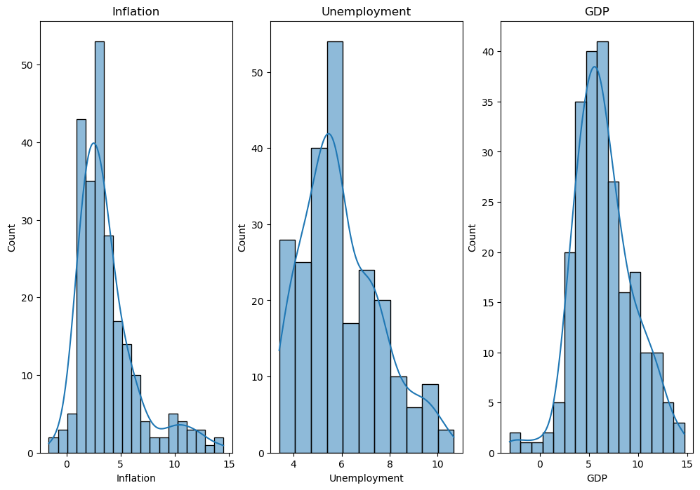

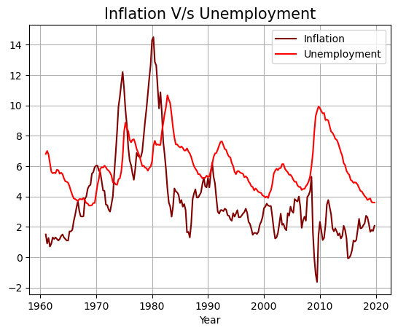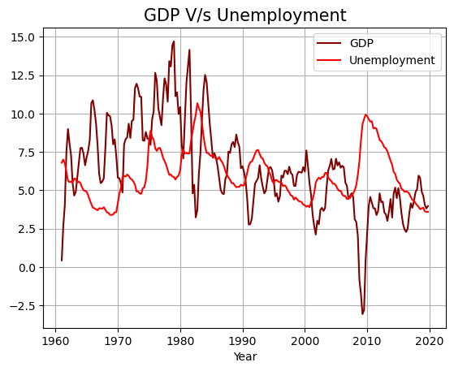

• From 1960 to 1980, the USA saw a unique positive relationship between unemployment and inflation, a period known as stagflation. Both inflation and unemployment rose simultaneously, driven by oil price shocks and economic stagnation, disrupting the traditional inverse relationship expected from the Phillips Curve.

• The 2008 financial crisis also left a significant impact on the USA’s economy. During this period, GDP experienced a sharp decline, with inflation dropping into deflation at approximately -2.5%. This contraction reflected a severe downturn, as consumer demand and economic growth faltered under the effects of the global crisis.

• Regarding the distribution characteristics, both inflation and unemployment show positive skewness, meaning they have occasional high values that deviate from the norm. Inflation is leptokurtic, with sharp peaks and fat tails, reflecting frequent small changes and rare but significant inflation spikes. Unemployment is platykurtic, suggesting stability with fewer extreme changes, while GDP is mesokurtic, displaying a nearly normal distribution with moderate peaks and occasional outliers.

**REGRESSION ALGORITHMS**

**Linear Regression**

Linear Regression is a statistical method used to model the relationship between two or more variables by fitting a straight line through the data points. In simple linear regression, a dependent variable is predicted based on the value of an independent variable (predictor). The formula for a simple linear regression line is y = mx + b , where m represents the slope of the line and b is the y-intercept. Linear regression is useful for visualizing economic relationships, like here, Phillips Curve and Okun’s Law. For the Phillips Curve, linear regression is applied to analyse the inverse relationship between inflation and unemployment, capturing how changes in unemployment might affect inflation. Similarly, in Okun's Law, linear regression is used to examine the correlation between unemployment and GDP growth, showing how GDP growth can predict changes in unemployment. By graphing these relationships with linear regression lines, we gain insight into the strength and direction of these economic theories, enabling clearer analysis and potential predictions.

**R-Squared**

R-squared, or the coefficient of determination, is a statistical measure that shows how well data points fit a regression line. It indicates the proportion of the variance in the dependent variable that can be explained by the independent variable(s) in the model. R-squared values range from 0 to 1 (or 0% to 100%), where higher values suggest that a larger proportion of the data’s variance is captured by the model, indicating a stronger fit. For example, an R-squared of 0.80 means that 80% of the variation in the dependent variable is explained by the independent variable(s). However, R-squared alone does not confirm causation or the quality of a model and must be interpreted in conjunction with other metrics and contextual understanding.

**Mean Squared Error**

Mean Squared Error (MSE) is a measure used to evaluate the accuracy of a regression model. It is calculated by taking the average of the squared differences between the actual values and the values predicted by the model. MSE provides a quantitative measure of how close the predicted values are to the actual data points; a lower MSE indicates better predictive accuracy. Since it squares the errors, MSE emphasizes larger errors, which can be useful for identifying models that fit well overall but may struggle with certain extreme values. However, because it’s in squared units, interpreting MSE requires contextual knowledge of the data’s scale.

**PHILLIPS CURVE**

**JAPAN**

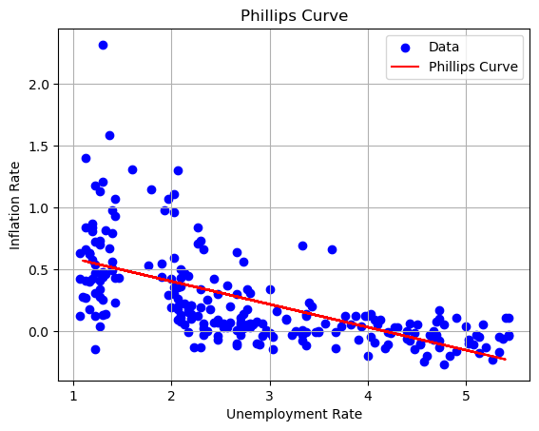

Interpretation

The given diagram shows Phillips Curve for Japan which illustrates an inverse relationship between unemployment and inflation, suggesting that as unemployment falls, inflation tends to rise, and vice versa. This pattern is supported by a negative correlation of -0.61, indicating that inflation and unemployment generally move in opposite directions. However, Japan’s unique economic conditions, such as an aging population, low consumer demand, and deflationary pressures, make this relationship more nuanced. Unlike many other economies, Japan’s inflation often remains low even with low unemployment, as limited demand and cautious spending habits temper inflationary pressures. This moderated response suggests that, while Japan’s labor market dynamics can influence inflation, the country’s structural factors, such as demographics and economic growth trends, dampen the strength of this relationship. Consequently, Japan’s Phillips Curve reflects a softer inverse relationship between unemployment and inflation, shaped by its distinct economic environment, yet still provides insights into the interplay between these two variables.

**PHILLIPS CURVE**

**USA**

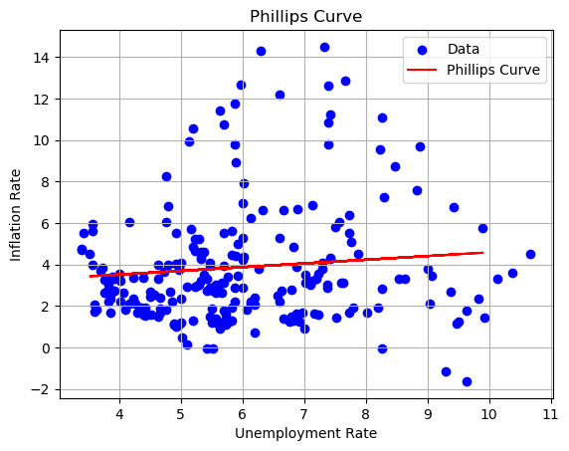

Interpretation

The initial findings indicate that the Phillips Curve may not hold true in this case, as a positive relationship is observed between unemployment and inflation, with a correlation of 0.14. Typically, the Phillips Curve suggests an inverse relationship, where lower unemployment leads to higher inflation and vice versa. However, this positive correlation suggests that both variables tend to rise or fall together in this specific context. This deviation could be attributed to unique economic conditions, such as inflationary expectations, external shocks, or structural factors influencing the labor market and price levels. Thus, the standard Phillips Curve relationship may not apply in this instance.

To check the reason for this positive relation, the data will be divided into two parts in order to examine a cross-sectional analysis.

**Cross-Sectional Analysis (USA)**

**1961-1983**

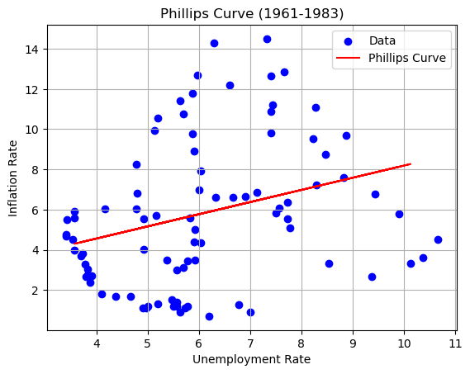

Interpretation

* The result showing a positive relationship between unemployment and inflation challenges the traditional Phillips Curve theory, which suggests an inverse relationship. Typically, as unemployment decreases, inflation rises due to increased demand for goods and services, leading to higher wages and prices. However, in this case, the positive correlation indicates that both inflation and unemployment may rise or fall together, which deviates from the typical pattern predicted by the Phillips Curve.
* During this period, the United States experienced significant economic prosperity, particularly with the post-World War II baby boomer generation entering the workforce. The economy was characterized by low unemployment rates, strong economic growth, and expanding job opportunities. This resulted in both rising wages and inflation, reflecting a positive shift in both variables. The economic boom led to increased consumer demand, and while employment levels were high, inflation also began to rise due to the higher demand for goods and services, thus creating a positive relationship between unemployment and inflation in this particular context

**Cross-Sectional Analysis (USA)**

**1984-2019**

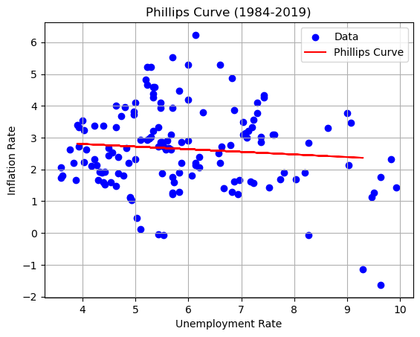

Interpretation

* In this section, the Phillips Curve reveals a negative relationship between unemployment and inflation, as evidenced by the downward-sloping regression line. This negative slope aligns with the traditional Phillips Curve theory, which suggests that lower unemployment generally leads to higher inflation, and vice versa. The visual representation of this inverse relationship implies that, during this period, the two variables moved in opposite directions, with a reduction in unemployment tending to correspond with an increase in inflation.
* From 1984 to 2019, the correlation between unemployment and inflation stands at -0.13, which, while relatively weak, still indicates a slight inverse relationship. This supports the Phillips Curve concept, where lower unemployment is typically associated with higher inflation. Despite the modest correlation, the data reinforces the idea that the Phillips Curve holds to some extent during this period, with inflation and unemployment exhibiting the expected negative relationship, consistent with economic models that predict inverse dynamics between these two variables.

**OKUN’s LAW**

**Japan**

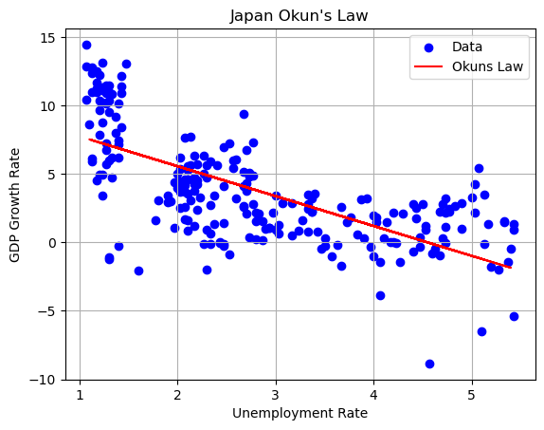

Interpretation

The regression model visualization of Okun’s Law reveals a negatively sloped curve, indicating an inverse relationship between GDP growth and unemployment. This means that as GDP growth increases, unemployment tends to decrease, and conversely, when GDP growth slows down, unemployment rises. This negative correlation supports the fundamental principle of Okun’s Law, which suggests that for every percentage point increase in the GDP growth rate, unemployment tends to decrease by a certain proportion. The curve visually reinforces the idea that economic expansion typically leads to job creation, while economic contraction is often associated with higher unemployment rates.

**USA**

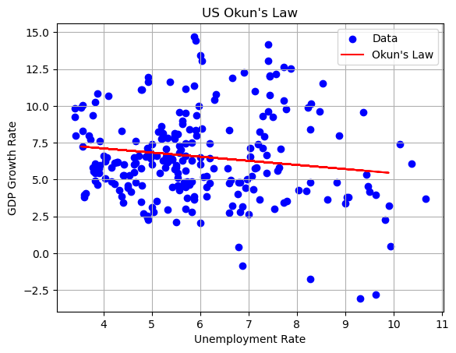

Interpretation

The diagram for the USA shows a slightly flatter but still negatively sloped curve, indicating a weaker yet consistent inverse relationship between GDP growth and unemployment. This means that while higher GDP growth typically leads to reductions in unemployment, the effect is less pronounced in the USA compared to other countries, such as Japan. The flatter slope suggests that changes in GDP growth have a more moderate impact on unemployment, which can be attributed to factors like labor market shifts, technological advancements, and a diversified economy with resilient sectors. Over the years, the USA has seen a structural shift from manufacturing jobs to service and technology sectors, which are less sensitive to short-term GDP fluctuations. Additionally, fiscal and monetary policies have played a role in stabilizing economic cycles, further contributing to this moderated relationship. Overall, the flatter curve reflects a nuanced economic dynamic where growth influences unemployment but with reduced sensitivity.

**PERFORMANCE METRICS**

**Japan**

**Phillips Curve**

* **Coefficients-> -0.18**
* **R-Squared-> 0.41**
* **Mean Squared Error-> 0.06**

**Okun’s Law**

* **Coefficients-> -2.18**
* **R-Squared-> 0.35**
* **Mean Squared Error-> 9.33**
* The Phillips Curve analysis for Japan shows a weak inverse relationship between unemployment and inflation, with a coefficient of -0.18 indicating that changes in unemployment have only a small effect on inflation. An R-squared of 0.41 reveals that unemployment explains just 41% of inflation’s variability, while a low Mean Squared Error of 0.06 indicates modest prediction accuracy.
* Japan’s Okun’s Law analysis reveals a notable inverse relationship between GDP growth and unemployment, with a coefficient of -2.18, indicating that unemployment tends to decrease by about 2.18% for each 1% increase in GDP. However, an R-squared of 0.35 shows that only 35% of unemployment variance is explained by GDP growth, and a high Mean Squared Error of 9.33 points to limited prediction accuracy.

**USA (1984-2019)**

**Phillips Curve**

* **Coefficients-> 0.6**
* **R-Squared-> 0.02**
* **Mean Squared Error-> 2.26**

**Okun’s Law**

* **Coefficients-> -0.27**
* **R-Squared-> -0.04**
* **Mean Squared Error-> 9.28**
* The USA’s Phillips Curve analysis shows a weak and unconventional relationship between inflation and unemployment, with a coefficient of 0.6 indicating a slight positive correlation between the two. The low R-squared of 0.02 suggests that only 2% of inflation variability is explained by unemployment. A Mean Squared Error of 2.26 indicates moderate prediction inaccuracy, pointing to the influence of other factors on inflation in the USA.
* The analysis of Okun’s Law for the USA reveals a weak inverse relationship between GDP growth and unemployment, with a small coefficient of -0.27 indicating that unemployment slightly decreases as GDP grows. However, a negative R-squared value of -0.04 suggests that other factors, beyond GDP growth, are significantly influencing unemployment.

**CONCLUSION**

**Japan**

Japan’s economic conditions over the past several decades present a distinctive combination of demographic challenges, structural policies, and external pressures, all of which have shaped its overall economic trajectory. A key feature of Japan’s economy is its persistently low and stable inflation, a result of the aging population, low birth rates, and a series of unconventional monetary policies aimed at stimulating demand and driving inflation. The country’s limited population growth has contributed significantly to low consumer demand, which restricts inflationary pressures despite government efforts to meet inflation targets. Additionally, Japan’s labor force is shrinking, leading to a decline in the potential for economic expansion. These demographic constraints, coupled with structural policies designed to counteract deflation and promote economic stability, have led to a unique inflationary environment. The prolonged demographic shift towards an older population has meant that wage growth has been subdued, further dampening inflationary expectations. As a result, Japan’s economy has been largely immune to the typical wage-price spiral that often drives inflation in other industrialized nations, with prices remaining remarkably stable.

These demographic challenges are also evident in Japan’s long-term GDP trends, which have shown a gradual decline interspersed with significant fluctuations. The country’s economic performance has been heavily impacted by events such as the bursting of the asset price bubble in the 1980s, which triggered a protracted period of stagnation and economic uncertainty. In the 1990s and early 2000s, Japan’s response to deflationary pressures involved structural reforms and fiscal measures aimed at stimulating demand, but growth remained sluggish. Recurring natural disasters, including the 2011 earthquake and tsunami, further disrupted economic activity and contributed to volatility in GDP. Japan’s dependency on exports and its position as a major player in the global market have added another layer of complexity to its economic stability. Shifts in global demand, changes in the value of the yen, and external crises such as the 2008 global financial meltdown have also had significant effects on the country’s GDP growth, amplifying the volatility of its economic performance. These factors, combined with persistent deflationary pressures, have prevented Japan from experiencing the steady, robust economic growth seen in other advanced economies.

Despite these fluctuations in GDP, Japan’s unemployment rate has remained relatively stable over the years, with a notable increase during the 2008 global financial crisis. Unlike many other nations where high unemployment typically accompanies economic downturns, Japan has largely maintained low unemployment levels, even during periods of economic stress. This stability in unemployment, coupled with the absence of significant inflationary pressure, has led to a weaker-than-usual inverse relationship between inflation and unemployment, as depicted in Japan’s Phillips Curve. Similarly, the negative relationship between GDP growth and unemployment, as illustrated by Okun’s Law, reflects the challenges Japan faces in maintaining consistent economic growth amidst demographic constraints, structural economic factors, and external market influences. The country’s unique economic situation highlights the complexity of achieving balanced growth in a context defined by low inflation, population decline, and ongoing structural adjustments. Japan’s experience demonstrates the need for a tailored approach to economic policy, where demographic shifts, global interdependencies, and the challenges of an aging workforce all intersect in shaping its economic outcomes.

**USA**

The economic evolution of the United States from 1960 to the present day offers a detailed narrative of how the country’s economy has responded to both domestic and global shifts, demonstrating a complex interplay between growth, inflation, unemployment, and economic policy. Between 1960 and 1980, the U.S. experienced a prolonged and unprecedented period of stagflation—a condition where inflation and unemployment rise simultaneously, defying the conventional Phillips Curve, which suggests an inverse relationship between the two. During this period, the country grappled with the aftershocks of multiple oil crises in the 1970s, which significantly increased energy costs and contributed to skyrocketing prices across the economy. These oil shocks resulted in reduced productivity and lower employment levels, creating a positive correlation between inflation and unemployment that challenged traditional economic models. This period of stagflation tested the validity of the Phillips Curve, revealing its limitations when confronted with supply-side shocks. As the U.S. struggled to manage both high inflation and high unemployment, policymakers were faced with the challenge of finding ways to stabilize the economy and restore growth.

In response to the persistent challenges of stagflation and the need to control rampant inflation, the U.S. adopted rigorous monetary policy measures beginning in the mid-1980s. The Federal Reserve, under Chairman Paul Volcker, implemented tight monetary policies by sharply raising interest rates to reduce inflation. While these measures initially led to a recession, they ultimately succeeded in bringing inflation down and curbing its damaging effects on the economy. The actions taken in the 1980s provided a long-term solution to the inflationary pressures of the previous decades, bringing the Phillips Curve back into alignment, with a more stable and downward-sloping relationship between inflation and unemployment. Over time, the U.S. economy was able to achieve more consistent growth, and the inverse relationship between inflation and unemployment was restored, reflecting the successful stabilization of inflation rates and the return to a more predictable economic cycle.

The United States’ GDP has experienced substantial fluctuations over the decades, including the stagflationary period of the 1970s, followed by robust economic growth in the 1980s and 1990s, and the significant downturn during the 2008 financial crisis. These fluctuations have had a direct impact on the labor market, reinforcing the validity of Okun’s Law, which posits that economic growth generally leads to reductions in unemployment, while periods of economic contraction result in increased unemployment. In the U.S., this relationship has proven to be particularly strong, with rapid growth in the 1980s and 1990s resulting in low unemployment levels, while the 2008 financial crisis and the economic disruptions caused by the COVID-19 pandemic led to significant job losses and increased unemployment. The resilience of Okun’s Law in the face of such economic shifts highlights the broader relationship between GDP and unemployment, demonstrating how fluctuations in one variable can lead to corresponding changes in the other. Together, the historical trends of GDP, inflation, and unemployment reflect the impact of monetary policy, supply shocks, and external factors in shaping the country’s long-term economic trajectory. The interplay between these factors underscores the complexity of economic management and the challenges policymakers face in maintaining a stable and growing economy.

**Bibliography**

**REFERENCES**

* **Pearson Blanchard Macroeconomics**
* **Peter B Clark and Douglas Laxton, Phillips Curve, Phillips Line and the unemployment costs**

**SOURCES**

* [**https://ideas.repec.org/a/aoq/ekonom/y2021i3p418-439.html - :~:text=According to the Phillips curve,potential output growth and unemployment.**](https://ideas.repec.org/a/aoq/ekonom/y2021i3p418-439.html#:~:text=According%20to%20the%20Phillips%20curve,potential%20output%20growth%20and%20unemployment.)
* [**https://www.investopedia.com/articles/economics/12/okuns-law.asp**](https://www.investopedia.com/articles/economics/12/okuns-law.asp)
* [**https://www.sciencedirect.com/science/article/abs/pii/S0304393224000333**](https://www.sciencedirect.com/science/article/abs/pii/S0304393224000333)
* [**https://www.aeaweb.org/articles?id=10.1257/pandp.20241051**](https://www.aeaweb.org/articles?id=10.1257/pandp.20241051)
* [**https://onlinelibrary.wiley.com/doi/abs/10.1111/jmcb.12420**](https://onlinelibrary.wiley.com/doi/abs/10.1111/jmcb.12420)
* [**https://link.springer.com/referenceworkentry/10.1007/978-3-319-57365-6_433-1**](https://link.springer.com/referenceworkentry/10.1007/978-3-319-57365-6_433-1)
* [**https://www.imf.org/en/Countries/USA**](https://www.imf.org/en/Countries/USA)
* **file:///The Slope of the Phillips Curve for Service Prices in Japan/ Regional Panel Data Approach**
* [**https://www.chicagofed.org/publications/chicago-fed-letter/2023/475?utm_referrer=https%3A%2F%2Fdzen.ru%2Fmedia%2Fid%2F6193bcabbc8de072f4e96546%2F64c4e3508a0a4207f7255395**](https://www.chicagofed.org/publications/chicago-fed-letter/2023/475?utm_referrer=https%3A%2F%2Fdzen.ru%2Fmedia%2Fid%2F6193bcabbc8de072f4e96546%2F64c4e3508a0a4207f7255395)